#### Use Case Diagram

**Admin:**

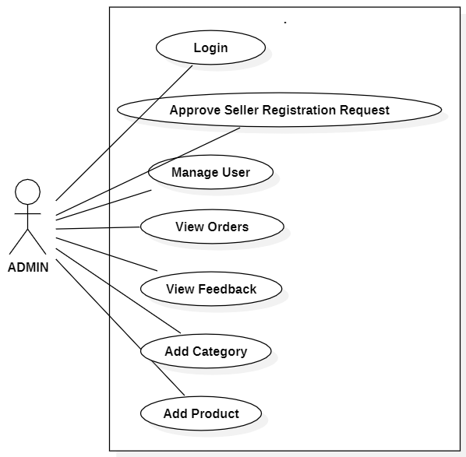

*Fig. Use case diagram for admin*

1. In admin use case diagram Admin is the Actor
2. Admin can handle following use cases:
3. Login
4. Approve Seller Registration Request
5. Manage User
6. View Orders
7. View Feedback
8. Add Category
9. Add Product

**Consumer:**

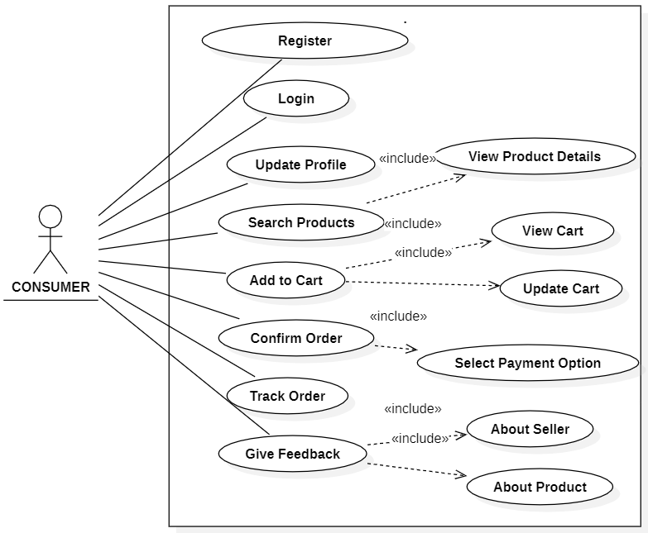

*Fig. Use case diagram for consumer*

1. In Consumer use case diagram Consumer is the Actor.
2. Consumer can handle following use cases:
3. Register
4. Login
5. Update Profile
6. Search Products
7. Add to cart
8. Confirm Order
9. Track Order
10. Give Feedback

**Seller:**

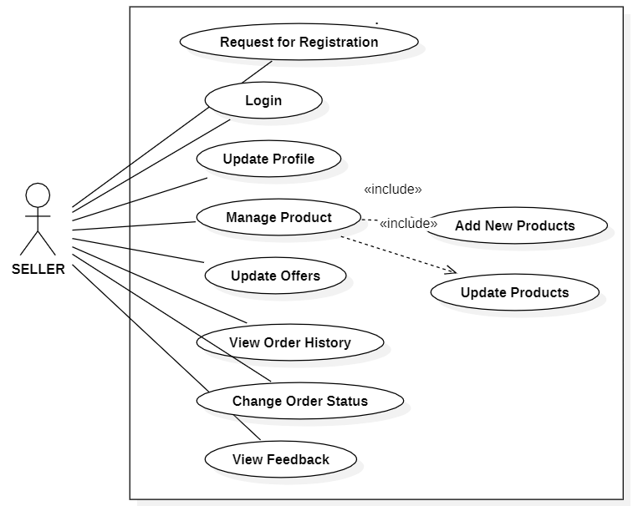

*Fig. Use case diagram for seller*

1. In Seller use case diagram Seller is the Actor.
2. Seller can handle following use cases:
3. Request for Registration
4. Login
5. Update Profile
6. Manage Product
7. Update Offers
8. View Order History
9. Change Order Status
10. View Feedback